**PROJECT REPORT**

Sales Dashboard Analysis

**Name** – Abhishek Satpute

**Project Title** – Sales Dashborad Analysis

**Date** – 2 Jan 2025

**Technology** – Tableau

**Project Description:**

The project focuses on the development and analysis of a sales dashboard that visualizes key performance indicators (KPIs) related to sales, profit, and quantities for a given time period. The dashboard aims to provide a comprehensive overview of the company’s sales performance by region, segment, state, and other metrics. This allows stakeholders to monitor business health and make data-driven decisions in real-time. The dashboard provides an interactive interface for tracking trends and identifying areas of success and improvement.

**Objective:**

The objectives of this sales dashboard project include:

* To visualize sales performance and trends in a user-friendly format.
* To track KPIs such as total sales, total profit, quantities sold, and segment-wise sales.
* To identify the highest and lowest performing regions, states, and sales representatives.
* To provide actionable insights based on the data visualized in the dashboard.
* To ensure that stakeholders can filter and interact with the data.
* To help make data-driven decisions for enhancing sales strategies.

**Key Performance Indicators (KPIs):**

#### ****1. Total Sales Trend****

* The trend line for **Total Sales** demonstrates a steady increase over time, indicating positive sales growth throughout the year.
* **Key Observation:** There is a noticeable peak during specific months, potentially due to seasonal demand, promotional campaigns, or market trends.
* **YOY Change:** The Year-Over-Year (YOY) growth of **20.36%** highlights strong overall performance in sales.

#### ****2. Total Profit Trend****

* The **Total Profit** trend shows periodic fluctuations but an overall upward trajectory, reflecting improved profitability.
* **Key Observation:** While the profit grows, its peaks are not as sharp as sales, potentially pointing to higher operational costs or price-sensitive markets during certain months.
* **YOY Change:** A **14.24%** profit increase signifies good financial health but room for further optimization.

#### ****3. Total Quantity Trend****

* The **Total Quantity** trend indicates a consistent rise, with spikes during certain months. This growth mirrors sales trends, confirming demand-driven growth.
* **Key Observation:** The **26.83%** YOY increase in quantities sold suggests growing customer demand and market expansion.

#### ****5. Insights from Trends****

* The upward trends in all three KPIs indicate that the company's strategy is yielding positive results.
* The alignment between sales and quantity trends suggests that volume growth is driving revenue.
* Profit growth, although positive, lags behind sales growth, suggesting a need to address cost efficiency or pricing strategies.

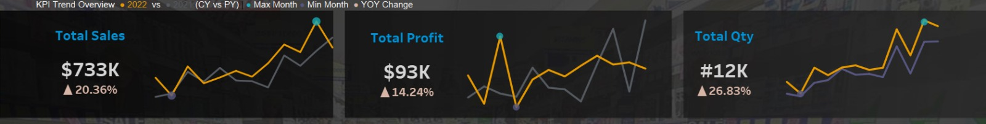

### ****Data Summary:****

* **Data Source:** Internal CRM, ERP, or sales tracking systems.
* **Date Range:** Full current year (CY 2022) with comparisons to previous years.
* **Data Dimensions:** Geographical (state, region), time-based (monthly), and business segmentation (consumer, corporate, home office).
* **Key Attributes:** Sales ($), Profit ($), Quantity (units), Segment (consumer, corporate, home office), and Manager-wise sales performance.

#### ****Key Graphs and Visualizations:****

1. **Sales and Profit Distribution by State:**

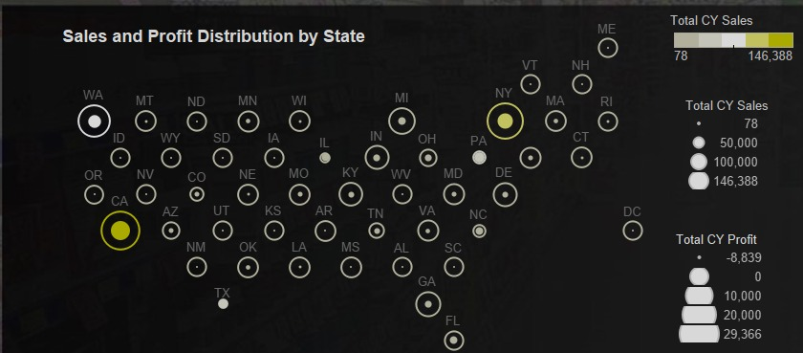

* + States like **California** and **New York** are leading in sales and profit.
  + Underperforming states include **Wyoming** and others below the national average.

1. **Monthly Sales by Segment:**

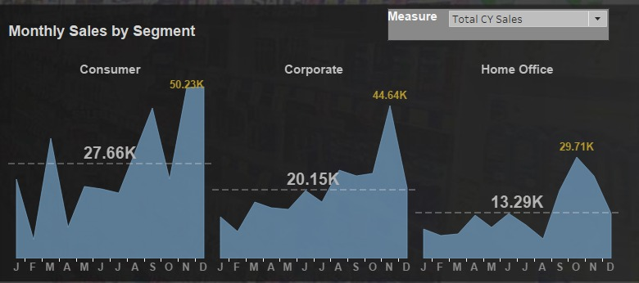

* + The **Consumer** segment drives the highest sales with a peak in December.
  + The **Corporate** and **Home Office** segments show consistent but lower sales.

1. **Sales by Location and Manager:**

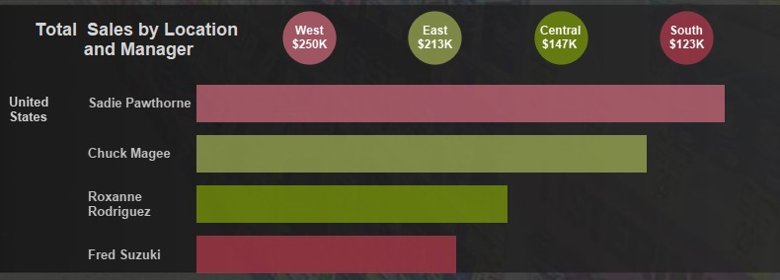

* + The **West** region performs well with $250K in total sales, while **South** lags with $123K.
  + Managers **Sadie Pawthorne** and **Chuck Magee** have the highest contributions to total sales.

1. **Sales Above and Below the U.S Sales Average:**

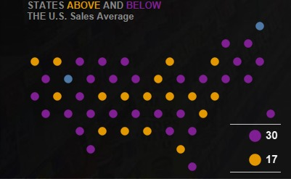

* 30 States are Above the Sales Average
* 17 States are Below the Sales Average

1. **Sales Above and Below the U.S Profit Average:**

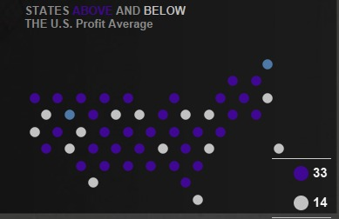

* 33 States are Above the Profit Average
* 14 States are Below the Profit Average

**Key Observations from Analysis:**

* **Regional Performance:** The West region outperforms others with the highest sales at $250K.
* **Monthly Trends:** The consumer segment dominates, especially in NovemberandDecember, while homeoffice sales peak during the last quarter.
* **State Analysis:** Certain states like California and New York show strong performance, while others, such as **Wyoming**, are underperforming both in sales and profit.

**Screenshot of Dashboard:**

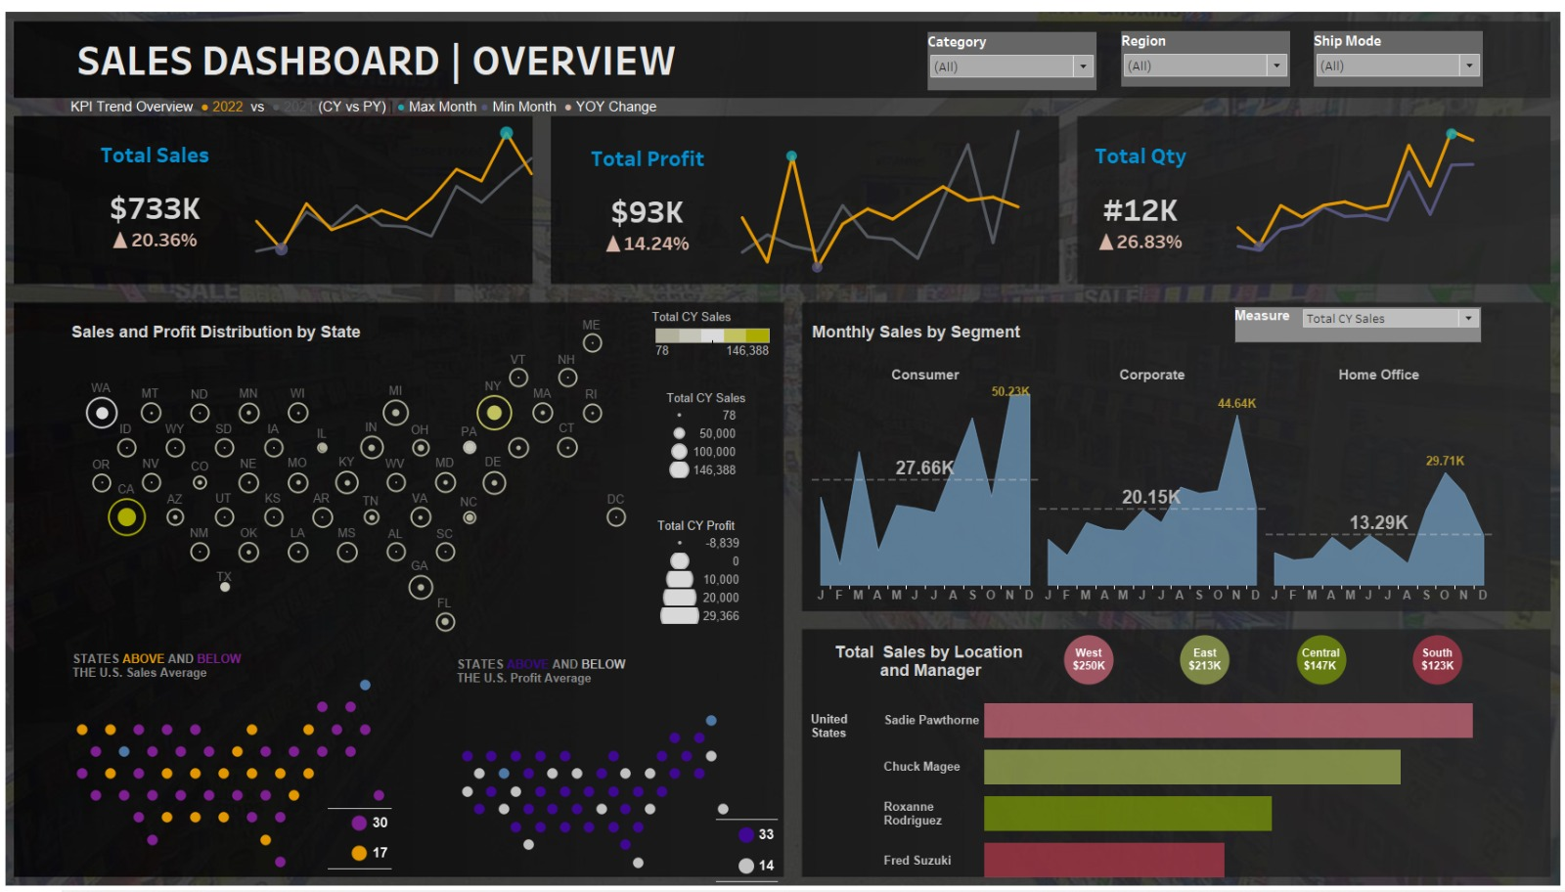

**Key Highlights:**

* **Interactive Filters:** Users can filter by category, region, and ship mode to tailor their view.
* **Geographic Insights:** Visualizing sales and profit distribution by state helps in identifying geographical trends.
* **Sales Performance by Segment:** Monthly segment-wise sales analysis provides insights into consumer demand shifts.

### ****Recommendations:****

1. **Focus Marketing Efforts on Underperforming Regions:**
   * Increase promotional campaigns in **South** and underperforming states like **Wyoming** to drive sales.
2. **Optimize Profit Margins:**
   * Analyze pricing and cost structures in states reporting low profits to enhance margins.
3. **Leverage Peak Segments:**
   * Invest more resources in the **Consumer** segment during high-performing months (e.g., December) to maximize sales.
4. **Replicate Successful Strategies:**
   * Study the sales approaches in the **West** and **East** regions and apply them to underperforming regions.
5. **Enhance Manager Accountability:**
   * Encourage managers in lower-performing regions to adopt the strategies of top performers like **Sadie Pawthorne** and **Chuck Magee.**

**Conclusion:**

The sales dashboard provides a robust overview of the company’s sales and profitability across multiple dimensions. It highlights significant growth in sales and quantity sold, as well as areas requiring improvement, such as regional and segment profitability. By implementing the recommendations, the company can further optimize its sales strategies, enhance profitability, and sustain its growth trajectory.